**Titanic - Machine Learning from Disaster**

# Predicting survival on the Titanic



## Data Dictionary

**Variable Definition Key**

survival Survival 0 = No, 1 = Yes

|  |  |  |
| --- | --- | --- |
| pclass | Ticket class | 1 = 1st, 2 = 2nd, 3 = 3rd |
| sex | Sex |  |
| Age | Age in years |  |
| sibsp | # of siblings / spouses aboard the  Titanic |  |
| parch | # of parents / children aboard the  Titanic |  |
| ticket | Ticket number |  |
| fare | Passenger fare |  |
| cabin | Cabin number |  |
| embarked | Port of Embarkation | C = Cherbourg, Q = Queenstown, S =  Southampton |

|  |
| --- |
| *#importing the libraries* **import** pandas **as** pd **import** numpy **as** np **import** matplotlib.pyplot **as** plt **import** seaborn **as** sns |

In [ ]:

|  |
| --- |
| df **=** pd**.**read_csv('titanic_train.csv') df**.**head() |

In [ ]:

Out[ ]: **PassengerId Survived Pclass Name Sex Age SibSp Parch Ticket Fa**

Barkworth,

Mr. Algernon

**0** 631 1 1 male 80.0 0 0 27042 30.00

Henry

Wilson

|  |  |  |  |  |  |  |  |  |  |  |  |  |
| --- | --- | --- | --- | --- | --- | --- | --- | --- | --- | --- | --- | --- |
| **1** |  | 852 | 0 | 3 | Svensson,  Mr. Johan | male | 74.0 | 0 |  | 0 | 347060 | 7.77 |
| **2** |  | 97 | 0 | 1 | Goldschmidt,  Mr. George B | male | 71.0 | 0 |  | 0 | PC 17754 | 34.65 |
| **3** |  | 494 | 0 | 1 | Artagaveytia, Mr. Ramon | male | 71.0 | 0 |  | 0 | PC 17609 | 49.50 |
| **4** |  | 117 | 0 | 3 | Connors, Mr. Patrick | male | 70.5 | 0 |  | 0 | 370369 | 7.75 |

In [ ]: df**.**shape

Out[ ]: (891, 12)

# Data Preprocessing

In [ ]: *#removing the columns* df **=** df**.**drop(columns**=**['PassengerId','Name','Cabin','Ticket'], axis**=** 1)

In [ ]: df**.**describe()

Out[ ]: **Survived Pclass Age SibSp Parch Fare**

|  |  |  |  |  |  |  |
| --- | --- | --- | --- | --- | --- | --- |
| **count** | 891.000000 | 891.000000 | 891.000000 | 891.000000 | 891.000000 | 891.000000 |
| **mean** | | 0.383838 | 2.308642 | 29.361582 | 0.523008 | 0.381594 | 32.204208 | |
| **std** | | 0.486592 | 0.836071 | 13.019697 | 1.102743 | 0.806057 | 49.693429 | |
| **min** | | 0.000000 | 1.000000 | 0.420000 | 0.000000 | 0.000000 | 0.000000 | |
| **25%** | | 0.000000 | 2.000000 | 22.000000 | 0.000000 | 0.000000 | 7.910400 | |
| **50%** | | 0.000000 | 3.000000 | 28.000000 | 0.000000 | 0.000000 | 14.454200 | |
| **75%** | | 1.000000 | 3.000000 | 35.000000 | 1.000000 | 0.000000 | 31.000000 | |
| **max** | | 1.000000 | 3.000000 | 80.000000 | 8.000000 | 6.000000 | 512.329200 | |

In [ ]: *#checking data types* df**.**dtypes

Out[ ]: Survived int64

Pclass int64

Sex object

Age float64

SibSp int64

Parch int64

Fare float64

Embarked object

dtype: object

In [ ]: *#checking for unique value count* df**.**nunique()

Out[ ]: Survived 2

Pclass 3

Sex 2

Age 88

SibSp 7

Parch 7

Fare 248

Embarked 3

dtype: int64

In [ ]: *#checking for missing value count* df**.**isnull()**.**sum()

|  |  |
| --- | --- |
| Out[ ]: | Survived 0  Pclass 0  Sex 0  Age 0  SibSp 0  Parch 0  Fare 0 Embarked 2 dtype: int64  **Refining the data** |

In [ ]: *# replacing the missing values* df['Age'] **=** df['Age']**.**replace(np**.**nan,df['Age']**.**median(axis**=**0)) df['Embarked'] **=** df['Embarked']**.**replace(np**.**nan, 'S')

In [ ]: *#type casting Age to integer* df['Age'] **=** df['Age']**.**astype(int)

In [ ]: *#replacing with 1 and female with 0* df['Sex'] **=** df['Sex']**.**apply(**lambda** x : 1 **if** x **==** 'male' **else** 0)

**Categorising in groups i.e. Infant(0-5), Teen (6-20), 20s(21-30), 30s(31-**

## 40), 40s(41-50), 50s(51-60), Elder(61-100)

In [ ]: *# creating age groups - young (0-18), adult(18-30), middle aged(30-50), old (50*df['Age'] **=** pd**.**cut(x**=**df['Age'], bins**=**[0, 5, 20, 30, 40, 50, 60, 100], labels **=** [

# Exploratory Data Analysis

## Plotting the Countplot to visualize the numbers

|  |
| --- |
| *# visulizing the count of the features* fig, ax **=** plt**.**subplots(2,4,figsize**=**(20,20)) sns**.**countplot(x **=** 'Survived', data **=** df, ax**=** ax[0,0]) sns**.**countplot(x **=** 'Pclass', data **=** df, ax**=**ax[0,1]) sns**.**countplot(x **=** 'Sex', data **=** df, ax**=**ax[0,2]) sns**.**countplot(x **=** 'Age', data **=** df, ax**=**ax[0,3]) sns**.**countplot(x **=** 'Embarked', data **=** df, ax**=**ax[1,0]) sns**.**histplot(x **=** 'Fare', data**=** df, bins**=**10, ax**=**ax[1,1]) sns**.**countplot(x **=** 'SibSp', data **=** df, ax**=**ax[1,2]) sns**.**countplot(x **=** 'Parch', data **=** df, ax**=**ax[1,3]) |

In [ ]:

Out[ ]: <Axes: xlabel='Parch', ylabel='count'>

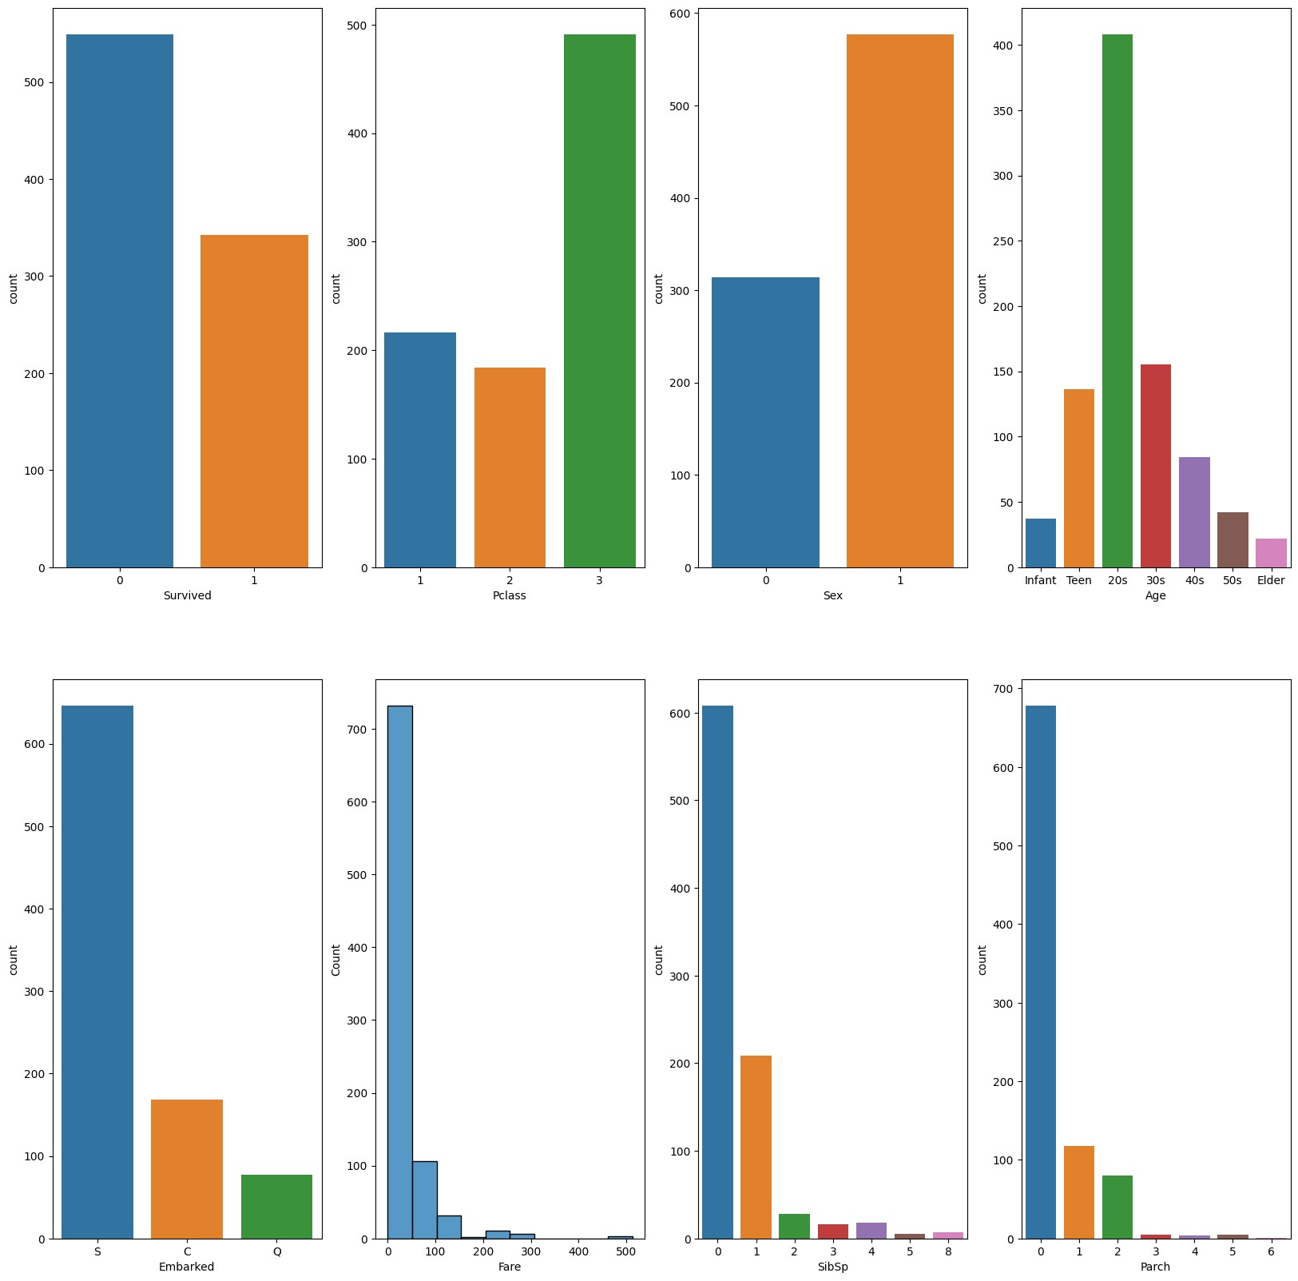

## Visualizing the replationship between the features

|  |
| --- |
| fig, ax **=** plt**.**subplots(2,4,figsize**=**(20,20)) sns**.**countplot(x **=** 'Sex', data **=** df, hue **=** 'Survived', ax**=** ax[0,0]) sns**.**countplot(x **=** 'Age', data **=** df, hue **=** 'Survived', ax**=**ax[0,1]) sns**.**boxplot(x **=** 'Sex',y**=**'Fare', data **=** df, hue **=** 'Pclass', ax**=**ax[0,2]) sns**.**countplot(x **=** 'SibSp', data **=** df, hue **=** 'Survived', ax**=**ax[0,3]) sns**.**countplot(x **=** 'Parch', data **=** df, hue **=** 'Survived', ax**=**ax[1,0]) |

In [ ]:

sns**.**scatterplot(x **=** 'SibSp', y **=** 'Parch', data **=** df,hue **=** 'Survived', ax**=**ax[1,1] sns**.**boxplot(x **=** 'Embarked', y **=**'Fare', data **=** df, ax**=**ax[1,2]) sns**.**pointplot(x **=** 'Pclass', y **=** 'Survived', data **=** df, ax**=**ax[1,3])

Out[ ]: <Axes: xlabel='Pclass', ylabel='Survived'>

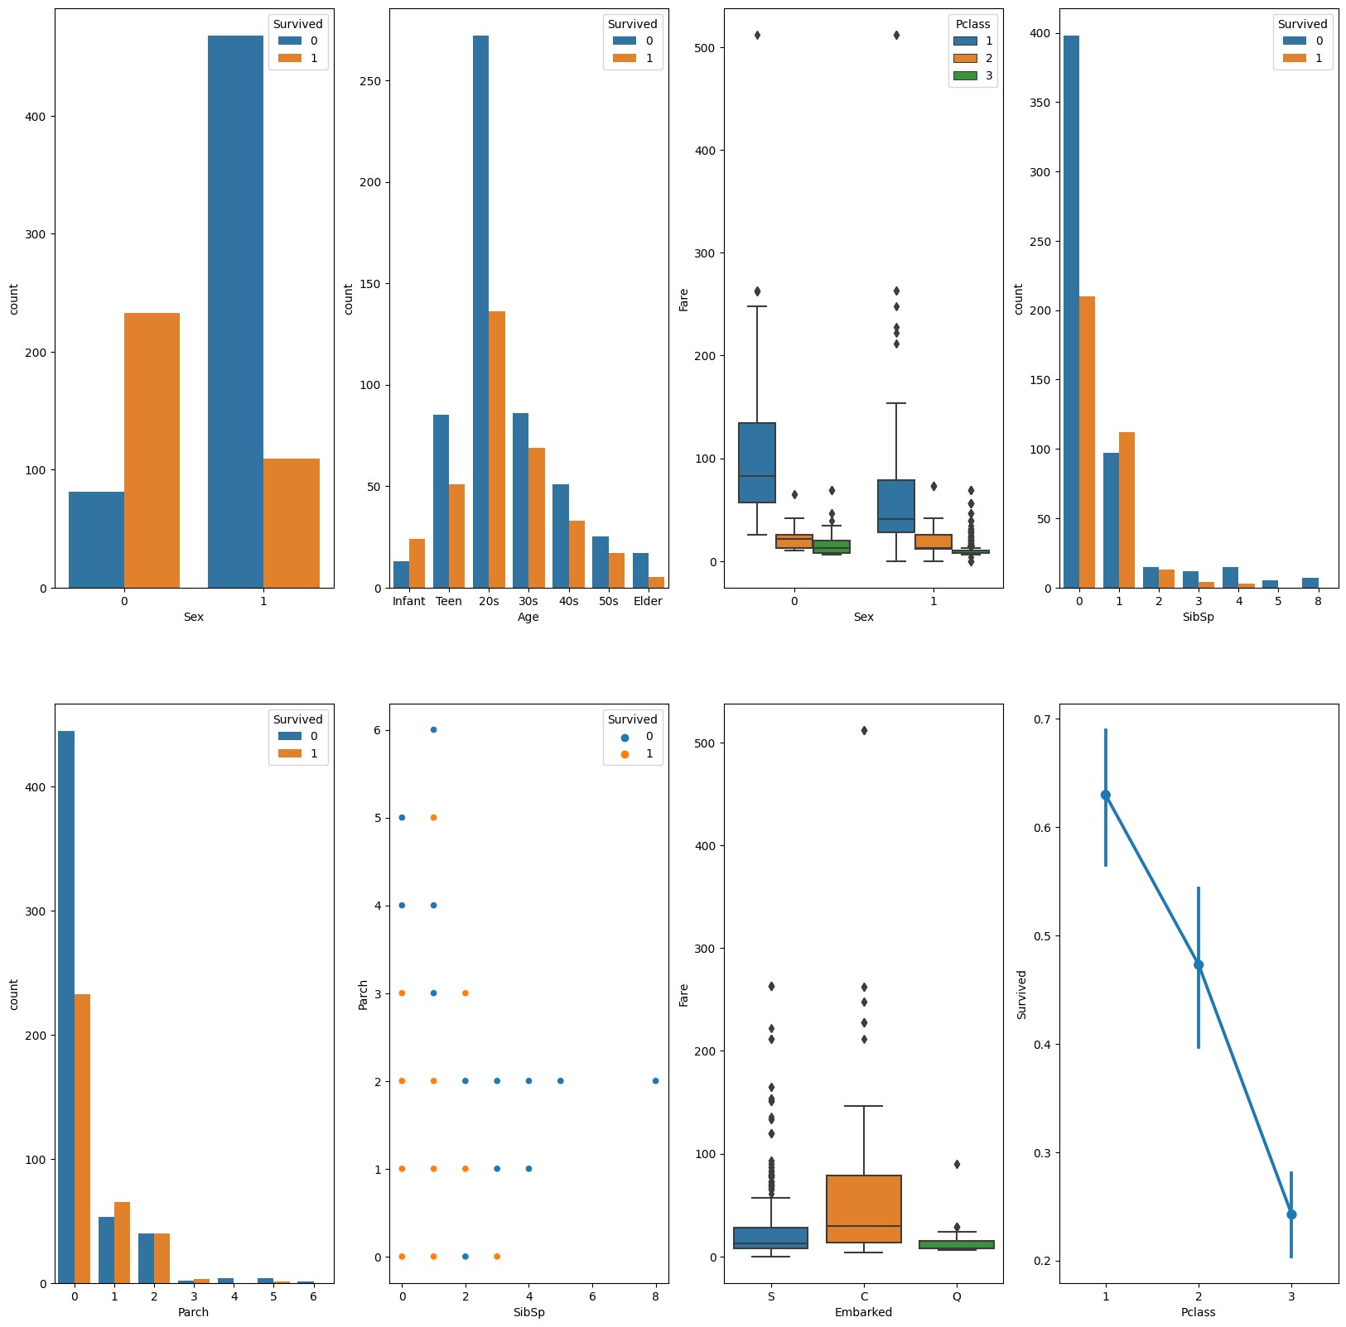

# Data Preprocessing 2

|  |
| --- |
| **from** sklearn **import** preprocessing le **=** preprocessing**.**LabelEncoder() le**.**fit(['S','C','Q']) df['Embarked'] **=** le**.**transform(df['Embarked']) |

In [ ]:

|  |
| --- |
| age_mapping **=** { 'infant': 0,  'teen': 1,  '20s': 2,  '30s': 3,  '40s': 4,  '50s': 5, 'elder': 6}  df['Age'] **=** df['Age']**.**map(age_mapping) df**.**dropna(subset**=**['Age'], axis**=** 0, inplace **=** **True**) |

In [ ]:

## Coorelation Heatmap

|  |
| --- |
| sns**.**heatmap(df**.**corr(), annot**=** **True**) |

In [ ]:

Out[ ]: <Axes: >

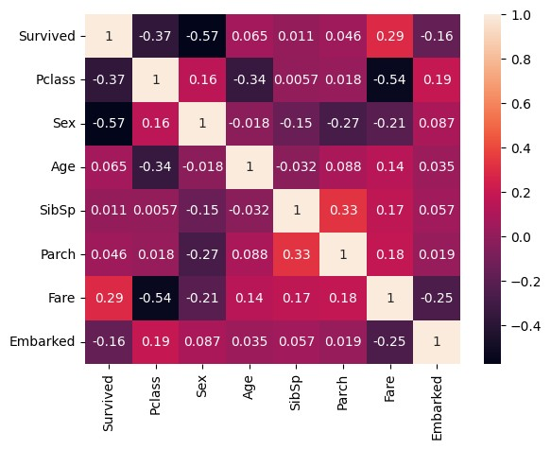

## Separating the target and independent variable

|  |
| --- |
| y **=** df['Survived']  x **=** df**.**drop(columns**=**['Survived']) |

In [ ]:

# Model Training

## Logistic Regression

|  |
| --- |
| **from** sklearn.linear_model **import** LogisticRegression lr **=** LogisticRegression() lr |

In [ ]:

Out[ ]: ▾LogisticRegression

LogisticRegression()

|  |
| --- |
| lr**.**fit(x,y) lr**.**score(x,y) |

In [ ]:

C:\Users\DELL\AppData\Local\Packages\PythonSoftwareFoundation.Python.3.11_qbz5n2k fra8p0\LocalCache\local-packages\Python311\site-packages\sklearn\linear_model\_lo gistic.py:458: ConvergenceWarning: lbfgs failed to converge (status=1): STOP: TOTAL NO. of ITERATIONS REACHED LIMIT.

Increase the number of iterations (max_iter) or scale the data as shown in: https://scikit-learn.org/stable/modules/preprocessing.html Please also refer to the documentation for alternative solver options:

https://scikit-learn.org/stable/modules/linear_model.html#logistic-regression n_iter_i = _check_optimize_result(

Out[ ]: 0.818577648766328

## Decision Tree Classifier

In [ ]: **from** sklearn.tree **import** DecisionTreeClassifier dtree **=** DecisionTreeClassifier() dtree

Out[ ]: ▾DecisionTreeClassifier

DecisionTreeClassifier()

In [ ]: dtree**.**fit(x,y) dtree**.**score(x,y)

Out[ ]: 0.9404934687953556

## Support Vector Machine (SVM)

In [ ]: **from** sklearn.svm **import** SVC svm **=** SVC() svm

Out[ ]: ▾SVC

SVC()

In [ ]: svm**.**fit(x,y) svm**.**score(x,y)

Out[ ]: 0.7024673439767779

## K-Nearest Neighbor

In [ ]: **from** sklearn.neighbors **import** KNeighborsClassifier knn **=** KNeighborsClassifier() knn

Out[ ]: ▾KNeighborsClassifier

KNeighborsClassifier()

In [ ]: knn**.**fit(x,y) knn**.**score(x,y)

Out[ ]: 0.8127721335268505

**From the above four model Decision Tree Classifier has the highest Training accuracy, so only Decision Tree Classifier will work on the Test Set.**

## Importing the test set

In [ ]: df2 **=** pd**.**read_csv('titanic_test.csv') df2**.**head()

Out[ ]: **PassengerId Survived Pclass Name Sex Age SibSp Parch Ticket**

Braund,

A/5

**0** 1 0 3 Mr. Owen male 22.0 1 0 7.2

21171

Harris

|  |  |  |  |  |  |  |  |  |  |  |  |
| --- | --- | --- | --- | --- | --- | --- | --- | --- | --- | --- | --- |
| **1** | 2 | 1 | 1 | Cumings,  Mrs. John  Bradley  (Florence  Briggs  Th... | female | 38.0 | 1 |  | 0 | PC 17599 | 71.2 |
| **2** | 3 | 1 | 3 | Heikkinen, Miss. Laina | female | 26.0 | 0 |  | 0 | STON/O2.  3101282 |  |
| **3** | 4 | 1 | 1 | Futrelle, Mrs.  Jacques  Heath  (Lily May Peel) | female | 35.0 | 1 |  | 0 | 113803 | 53.1 |
| **4** | 5 | 0 | 3 | Allen, Mr.  William Henry | male | 35.0 | 0 |  | 0 | 373450 |  |

7.9

8.0

|  |
| --- |
| *#removing the columns*  df2 **=** df2**.**drop(columns**=**['PassengerId','Name','Cabin','Ticket'], axis**=** 1) |

In [ ]:

# Data Preprocessing the Test set

|  |
| --- |
| df2['Age'] **=** df2['Age']**.**replace(np**.**nan,df2['Age']**.**median(axis**=**0)) df2['Embarked'] **=** df2['Embarked']**.**replace(np**.**nan, 'S') |

In [ ]:

|  |
| --- |
| *#type casting Age to integer* df2['Age'] **=** df2['Age']**.**astype(int) |

In [ ]:

In [ ]:

|  |  |  |  |  |  |  |  |  |
| --- | --- | --- | --- | --- | --- | --- | --- | --- |
| *#replacing* df2['Sex'] | *wi* **=** | *th 1 and female with 0* df2['Sex']**.**apply(**lambda** x : 1 | **if** | x **==** | 'male' | **else** | 0) |  |
|  |  |  |  |  |  |  |  |  |
| df2['Age'] | **=** | pd**.**cut(x**=**df2['Age'], bins**=**[0, | 5, | 20, | 30, 40, | 50, | 60, | 100], labels |
|  |  |  |  |  |  |  |  |  |
| le**.**fit(['S','C','Q'])  df2['Embarked'] **=** le**.**transform(df2['Embarke | | | d'] | ) |  |  |  |  |
|  | | | | |  |  |  |  |
| df2**.**dropna(subset**=**['Age'], axis**=** 0, inplace **=** **True**) | | | | | |  |  |  |
|  | | | | | |  |  |  |
| df2**.**head() | | | | | |  |  |  |

In [ ]:**=**

In [ ]:

In [ ]:

In [ ]:

Out[ ]: **Survived Pclass Sex Age SibSp Parch Fare Embarked**

**0** 0 3 1 2 1 0 7.2500 2

|  |  |  |  |  |  |  |  |  |
| --- | --- | --- | --- | --- | --- | --- | --- | --- |
| **1** | 1 | 1 | 0 | 3 | 1 | 0 | 71.2833 | 0 |
| **2** | 1 | 3 | 0 | 2 | 0 | 0 | 7.9250 | 2 |
| **3** | 1 | 1 | 0 | 3 | 1 | 0 | 53.1000 | 2 |
| **4** | 0 | 3 | 1 | 3 | 0 | 0 | 8.0500 | 2 |

## Separating the traget and independent variable

In [ ]: x **=** df2**.**drop(columns**=**['Survived']) y **=** df2['Survived']

# Predicting using Decision Tree Classifier

In [ ]: tree_pred **=** dtree**.**predict(x)

In [ ]: **from** sklearn.metrics **import** accuracy_score accuracy_score(y, tree_pred)

Out[ ]: 0.8959276018099548

## Confusion Matrix

In [ ]: **from** sklearn.metrics **import** confusion_matrix sns**.**heatmap(confusion_matrix(y,tree_pred),annot**=** **True**, cmap **=** 'Blues') plt**.**ylabel('Predicted Values') plt**.**xlabel('Actual Values') plt**.**title('confusion matrix') plt**.**show()

